Cipher Challenge 7: The Gold Bug

# Solve the message:

**Message:**

* What does the de-ciphered message say?

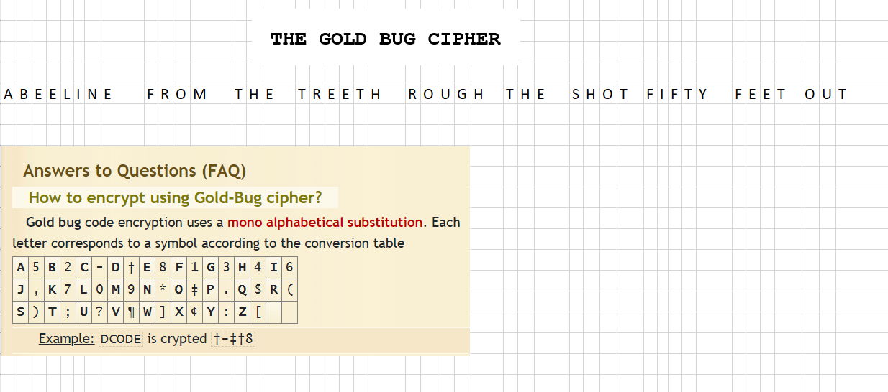

* How did they break the cipher in the 1840s

"The Gold Bug" is a short story by Edgar Allan Poe that involves a cipher, which the protagonist, William Legrand, deciphers to discover the location of a buried treasure. In the story, the cipher is a substitution cipher that uses symbols instead of letters.To break the cipher in the 1840s, Legrand used a combination of pattern recognition and frequency analysis, which are techniques commonly used in cryptanalysis.

# Explain the solution:

* What methods did you use to solve the cipher?

Research about the kesy online and match them multiple time in the excel

* How long did it take to solve the cipher?

**5 mins**

# Historical points or issues found:

What are some of the historical points or issues surrounding this cipher?

During World War II, the use of cryptography played a significant role in the outcome of the war. The German military, for example, used the Enigma machine to encrypt their messages, but the Allies eventually broke the cipher, which was a significant turning point in the war.

Similarly, the Japanese military used a complex cipher system called Purple to encrypt their diplomatic messages, but the United States was able to break the cipher, which helped the US in the Pacific War.

Hint: Use our text The Code Book and Wikipedia.